Experiment – 1
Power BI
Step by Step Log

Aim : To acquire data from multiple sources and perform data profiling using Microsoft Power BI in order to assess data quality, understand data structure, identify anomalies, and prepare data for further analytical processing.

Procedure:
Step – 1: Import CSV File
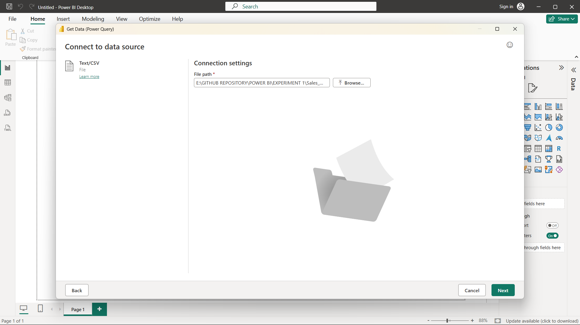
Description:
Launch Power BI Desktop and import the CSV file.
Home > Get Data > Text/CSV
Browse to Sales_Data.csv > Load
Step – 2: Import Excel File
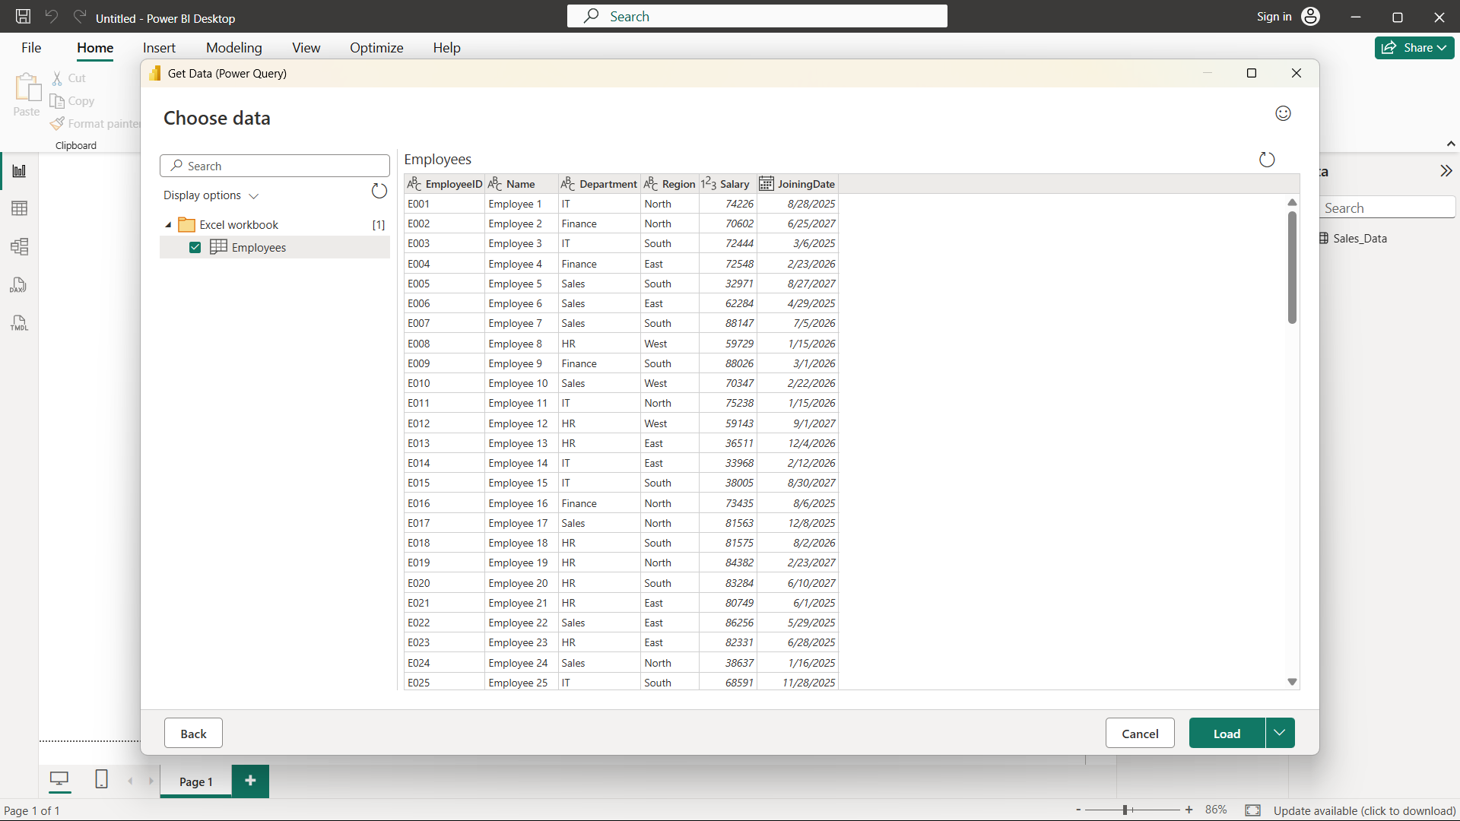
Description : Home > Get Data > Text/CSV
Browse to Sales_Data.csv > Load

Step- 3: Connect to the SQL database and import the Transactions table.
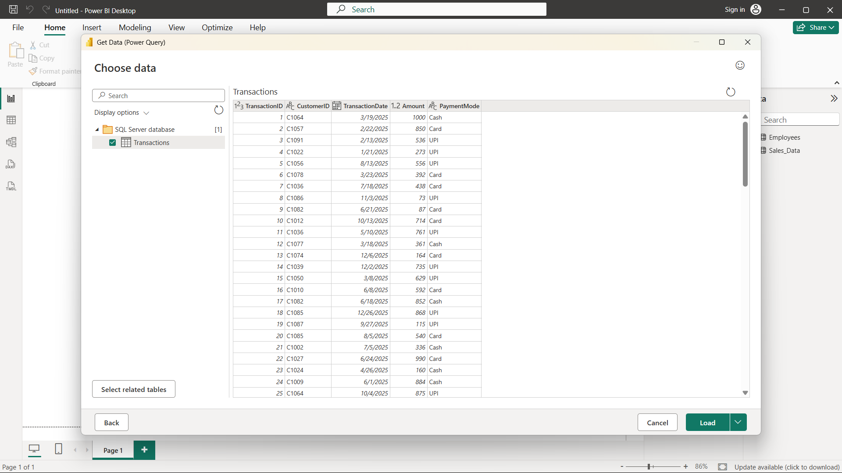

Description:
Home > Get Data > SQL Server
Enter server name and database details > Select Transactions table > Load
Verify that all three data sources appear in the Data pane on the right-hand side of the Power BI window.

Step 4: Open Power Query Editor
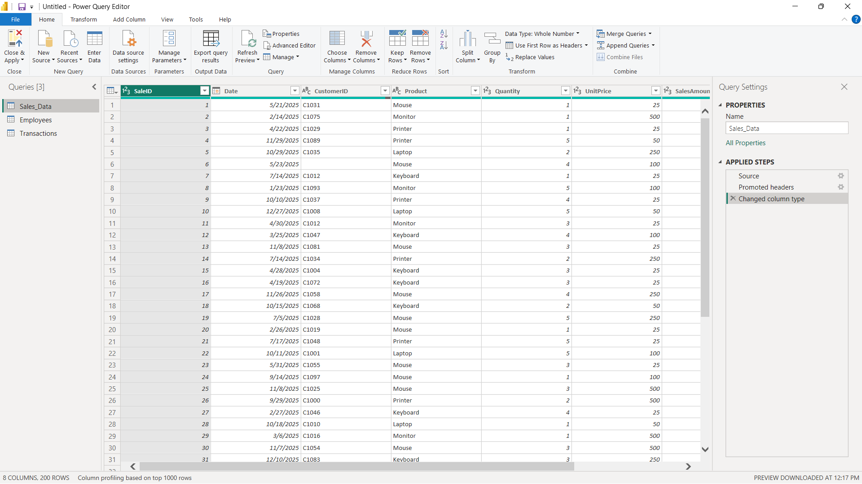
Description:
Home > Transform Data
Step 5: Enable data profiling features.
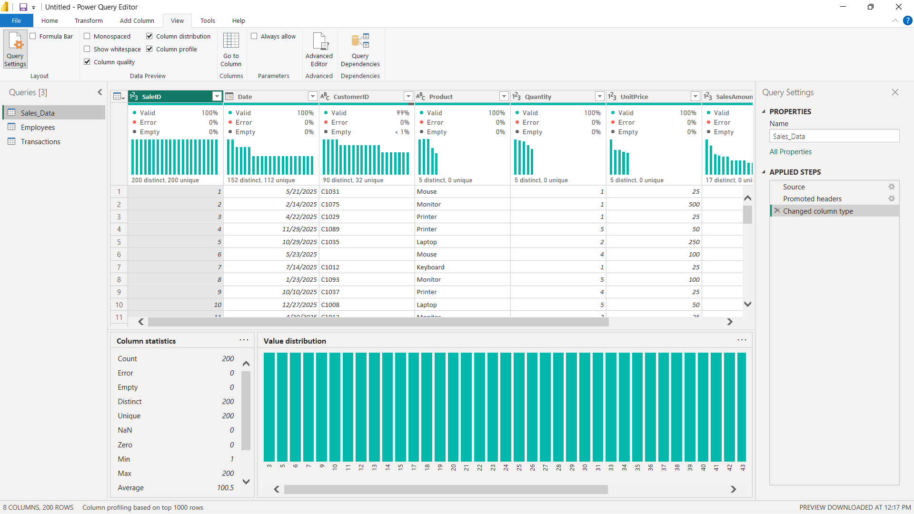
Description:
View tab > Tick Column Quality
View tab > Tick Column Distribution
View tab > Tick Column Profile
Select each column one at a time and observe the profiling statistics displayed below the data preview grid.
Step 6: Record profiling observations.
For each column in each dataset, observe and record:
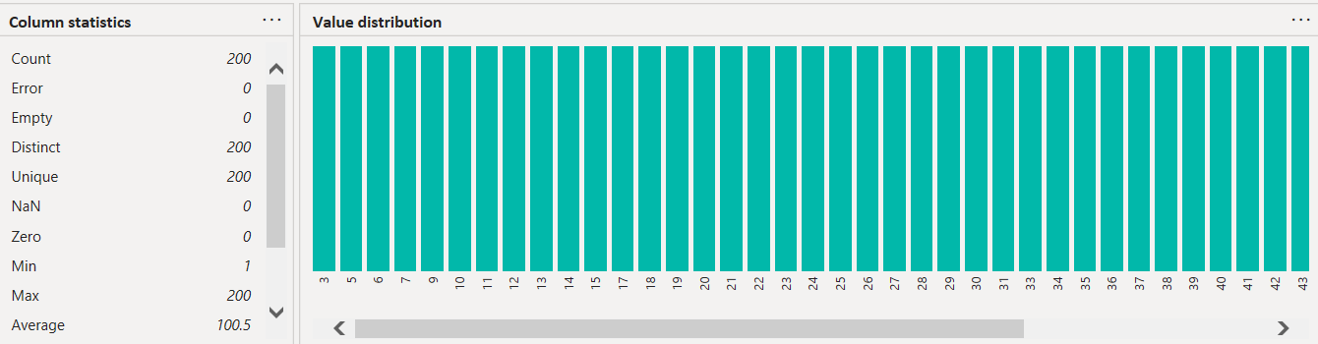
Description:
    - Data type and total row count.
    - Null/empty percentage from Column Quality.
    - Distinct and unique value counts from Column Distribution.
    - Minimum, maximum, mean, and standard deviation for numeric columns from Column Profile.
    - Any errors, mismatched data types, or unexpected values.

Step 7: Identify data quality issues from the profiling results.
Check for common issues such as:
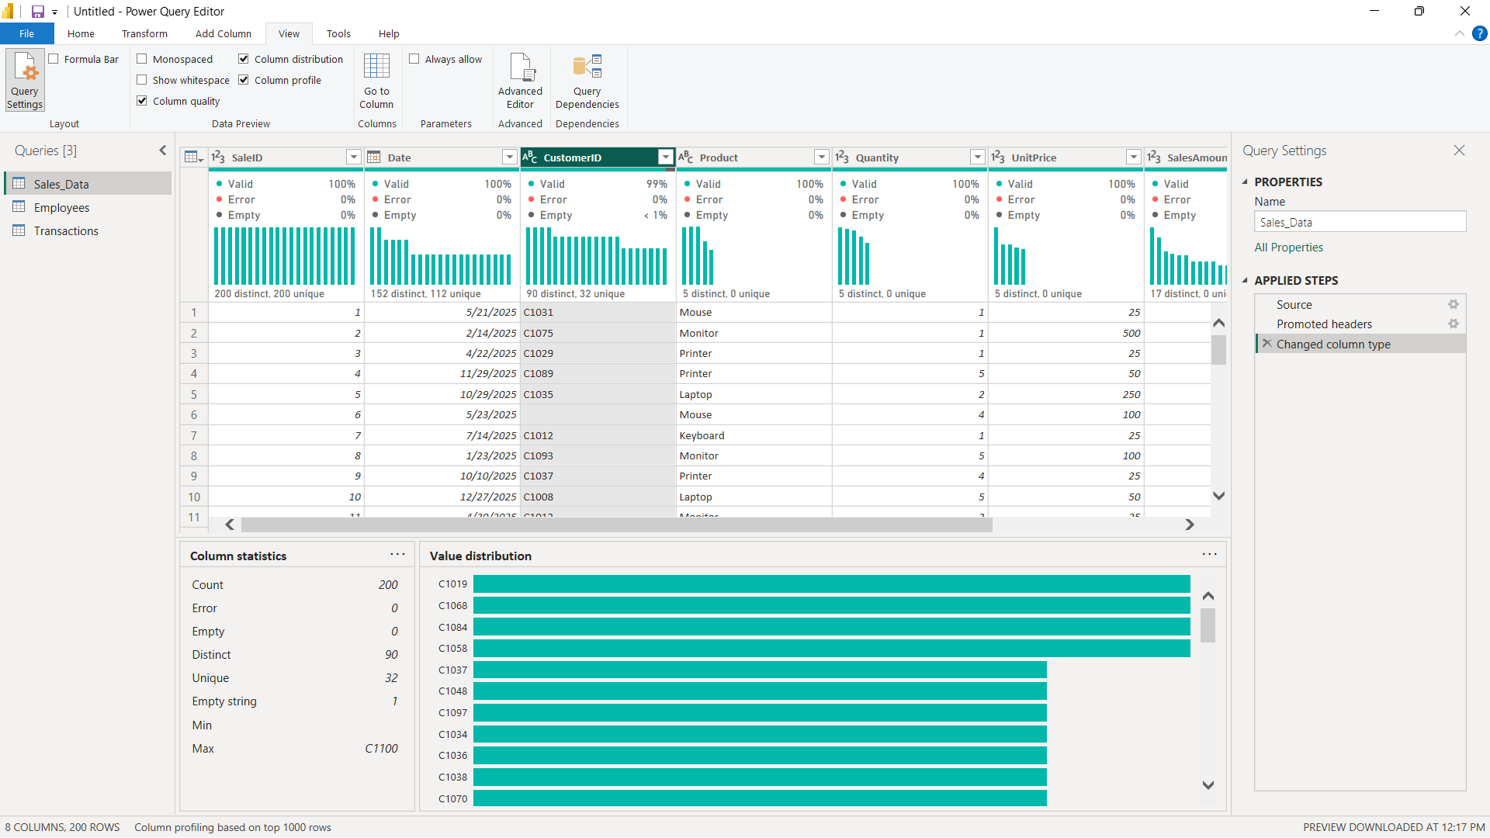
Description:
    - High null or empty values in important columns.
    - Columns containing only one unique value.
    - Numeric columns containing text values or incorrect data types.
    - Date values outside the expected range or future dates.
    - Duplicate records indicated by low uniqueness.

Step 8: Document the identified issues.
Record at least three data quality issues found during profiling and mention a suitable remediation action for each issue.

LEARNING OUTCOMES
  - Understood the concept of Business Intelligence and its role in data-driven decision-making.
  - Learned how to acquire data from different heterogeneous sources.
  - Learned how to import CSV, Excel, and SQL Server data into Power BI.
  - Gained practical experience with Microsoft Power BI Desktop.
  - Learned how to use SQL Server Management Studio for working with SQL-based data.
  - Learned how to use Power Query Editor for data profiling.
  - Understood the purpose of Column Quality, Column Distribution, and Column Profile.

